**Preventing injury to people sleeping rough in refuse containers**

## Guidance for Business in Southwark

## imgID44424009_jpg_gallery

Dec 2022

|  |  |
| --- | --- |
|  |  |

### About this guidance

This guidance is about preventing serious injury to people, including children, who may enter, play in or take shelter in commercial waste bins, communal domestic bins or charity bins.

A particularly vulnerable population at risk of injury in large waste bins is rough sleepers who may seek refuge. At least 11 people have died between 2009 and 2015, when they were tipped into waste collection and compaction vehicles. A national waste contractor has said that this number is increasing – reporting 31 instances in 2013, which rose to 175 in 2015 and was up again to 216 in 2016.

Southwark has the sixth highest number of rough sleepers in London so the likelihood of occurrence is relatively high.

## What businesses are most at risk?

* Businesses with bins with a capacity of over 660 litres
* Businesses located in areas where rough sleeping is known to be a problem
* Businesses in areas where there have been previous instances of people being found in waste storage areas and bins
* Businesses that store dry, ‘comfortable’ wastes known to be attractive to those seeking shelter e.g. paper, card, carpet and textiles
* Businesses that have bin storage areas in quiet locations with low footfall
* Businesses that have unsecured bin stores or unlockable bins

### Reducing and managing risks

All employers have a legal duty to protect the health, safety and welfare of people who may be affected by their work activities under the Health and Safety at Work Act 1974.

To reduce and manage the risks, you should consider:

**Risk Management**

Look at the risks, assess how serious they are and decide how to reduce them.

Any risk assessment should include all significant aspects relating to the storage and collection of commercial waste, including the possibility of people in bins.

A checklist has been included on page 7 at the end of this guidance to help you.

**Controls**

Put measures in place to control the environment around the bins and introduce work practices to reduce the likelihood of harm.

**Reporting incidents**

If a person is found in a bin, is injured and/ or taken from the site of the accident to a hospital for treatment, a report must be made to the Health and Safety Executive (HSE), under the Reporting of Injuries, Diseases and Dangerous Occurrences Regulations (RIDDOR) 1995.

**Training**

Train staff how to recognise the signs of rough sleeping in waste storage areas and bins, and what to do if they find someone. Some helpful tips have been included on pages 4 and 5 of this guidance.

**Police support**

The Business Crime Reduction Partnership Officers or local Police Community Support Officers (PCSO) can provide advice on security.

**Advice**

Speak to other local traders, business support groups or your waste contractor to share experiences, information and tips.

### Control measures to consider

#### imagesGUOA3WZ1 Check bins

* **Bang** on the side of the bin.
* **Lift the lid** of the bin and take a look. Staff must not put themselves at risk by climbing up or standing on stacked waste.
* **Check the bin’s content**. Do not rummage by hand.
* **Any unusual items.** Does the bin contain the type of waste expected? Check if there are items indicating it might be used or occupied e.g. carrier bags, rucksacks, luggage, bags, quilts, sleeping bags, blankets, etc.
* **Ensure your waste contractor is aware** of any local problem that you may have noticed.

****

#### Lock bins

* **Locking bins,** particularly overnight or when premises are unstaffed, minimises the risk of bins being occupied and reduces other hazards, such as fire.

#### Bin store design

* Keep a well maintained and **secure exterior**.
* Ensure it is a **well lit area**.
* Have a layout that minimises **blind spots**.
* Have **CCTV** and security devices.

**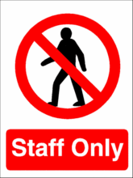**

#### Use of warning signs

* **Signs, labels or stickers** on bins or bin stores will not replace the control measures outlined above, but, they can remind staff and waste contractors to carry out a check.

#### cold Cold and wet weather

* During prolonged periods of cold or wet weather it is more likely rough sleepers will seek shelter. Please be extra vigilant during this time.

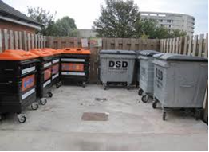 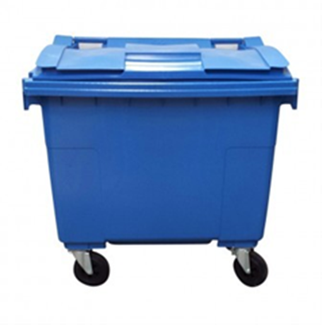

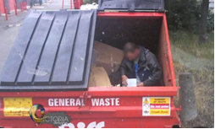 

### What to do if you find someone

Staff checking bins must be provided with instructions on what to do if they find a person, for example which manager to contact, where to find the equipment to help them get out of the bin safely and, if injured or unresponsive, to call the emergency services.

#### Recording incidents

* It is good practice to record all instances as a ‘near miss’ where a person is discovered inside a bin, even if no harm or damage has occurred.
* These records will assist you when reviewing your risk assessments. They can help with assessing whether your current arrangements are appropriate.

#### Rough sleepers under the influence

* Some rough sleepers may be under the influence of drugs or alcohol, or may suffer from a significant health problem. On discovery, they could react defensively and could pose a risk to untrained staff. This should be considered as part of the risk assessment.
* No attempt should be made to confiscate a person’s possessions or to restrain them if they wish to leave.
* Further information and guidance on managing violence at work is provided by HSE, this can be found at [www.hse.gov.uk/pubns/indg69.pdf](http://www.hse.gov.uk/pubns/indg69.pdf)

#### Homelessness support services

If you have found someone sleeping rough or you are worried about someone sleeping rough you can refer them to:

**The Manna Centre**

**12 Melior St**

**London, SE1 3QP**

or

**Streetlink** at [www.streetlink.org.uk](http://www.streetlink.org.uk)

### Further information and support

**Reporting incidents**

Health and Safety Executive, for reporting RIDDOR incidents and accidents - [www.hse.gov.uk/riddor](http://www.hse.gov.uk/riddor)

Street Link, for referring rough sleepers - [www.streetlink.org.uk/](http://www.streetlink.org.uk/)

**Support and guidance**

Health and Safety Executive – [www.hse.gov.uk](http://www.hse.gov.uk)

Southwark Council’s Health & Safety Team –[OHS@southwark.gov.uk](mailto:OHS@southwark.gov.uk)

Southwark Council’s Anti-Social Behaviour Team – [sasbu@southwark.gov.uk](mailto:sasbu@southwark.gov.uk)

Crimestoppers – 0800 555 111 or [www.crimestoppers-uk.org](http://www.crimestoppers-uk.org)

Waste Industry Safety & Health Forum, on guidance for managing access –

[WASTE-25-.pdf (wishforum.org.uk)](https://www.wishforum.org.uk/wp-content/uploads/2019/06/WASTE-25-.pdf)

Home Office, for tips on how to secure your business – <http://secureyourbusiness.homeoffice.gov.uk>

**Support networks**

Association of Town Centre Managers – [www.atcm.org](http://www.atcm.org)

British Retail Consortium – [www.brc.org.uk](http://www.brc.org.uk)

British Chambers of Commerce – 020 7565 2000 [www.britishchambers.org.uk](http://www.britishchambers.org.uk)

Federation of Small Businesses – [www.fsb.org.uk](http://www.fsb.org.uk)

Safer Neighbourhoods Ward Panel – [www.met.police.uk/saferneighbourhoods/involved.htm](http://www.met.police.uk/saferneighbourhoods/involved.htm)

### Checklist

**Name:** …………………………………………………………………………………………

**Address of business:** ………………………………………………………………………

**Date:** ……………..

|  |  |
| --- | --- |
| Measure | In place? |
| Bins and waste storage areas regularly checked for signs of rough sleeping |  |
| Lockable bins |  |
| Increased awareness and checks during prolonged inclement weather |  |
| Bin store secure |  |
| Bin store well lit |  |
| CCTV for bin store |  |
| Blind spots minimised |  |
| Warning signs on individual bins and bin store entrance to remind staff to check |  |
| Instruction to staff on what to do should someone be discovered |  |
| Instruction to staff on what to do if person is aggressive |  |
| All aware of homelessness support service contacts |  |
| Records kept and HSE notification process for all incidents where someone is found in a bin or injured |  |
| Guidance sought if you have further concerns or queries |  |