 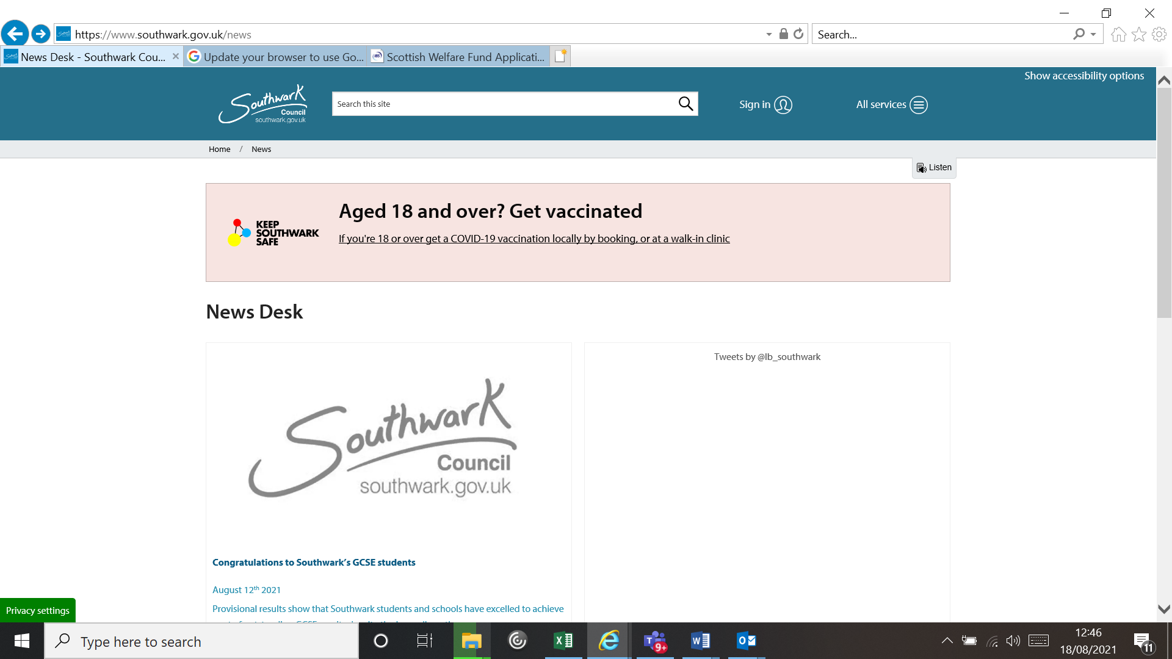

# Chambers Wharf Community Enhancement Fund Application Form

## Section 1: Project

|  |  |
| --- | --- |
| Project title |  |
| Name of organisation |  |
| Amount of funding requested |  |
| Project summary  (maximum 50 words) |  |

## Section 2: Applicant details

|  |  |
| --- | --- |
| Main contact |  |
| Position in organisation |  |
| Telephone |  |
| Email |  |
| Postal address |  |
| Name of organisation |  |
| Charity number  (if applicable) |  |
| Company number  (if applicable) |  |
| Organisation’s registered address |  |
| Website (if applicable) |  |

|  |  |  |  |  |
| --- | --- | --- | --- | --- |
| Which category does your organisation/group belong to? |  | Local Community and Voluntary Group | | |
|  | Co-operatives | | |
|  | Faith and Equalities Groups | | |
|  | Social Enterprises | | |
|  | Small-Medium Enterprises | | |
|  | Other | Please describe |  |

## Section 3: Eligibility

|  |  |  |  |  |
| --- | --- | --- | --- | --- |
| How will this project be delivered, through an organisation or collaboration? |  | Yes |  | No |
| If yes, please list the names of the organisations, which you will be delivering this project with. |  | | | |
| Please include an address where the main focus of the work will be.  (e.g. location of infrastructure to be installed, location of proposed event) |  | | | |

## Section 4: Planning a successful project - project plan

|  |  |  |  |  |
| --- | --- | --- | --- | --- |
| What are the main objectives of the project? | | | | |
| 1. |  | | | |
| 2. |  | | | |
| 3. |  | | | |
| 4. |  | | | |
| 5. |  | | | |
| Please describe the project (Maximum 300 words) | | | | |
|  | | | | |
| What is the start date? | |  | What is the end date? |  |
| How will you monitor progress against the above objectives? | | | | |

|  |  |  |  |
| --- | --- | --- | --- |
| Please outline the top three key risks associated with this project and how these will be mitigated. | | | |
| Risk | Description | | Mitigation Strategy |
| 1 |  | |  |
| 2 |  | |  |
| 3 |  | |  |
| What local research/consultation has been carried out to support this proposal? | |  | |
| Outline the community support for this project. | |  | |

## Planning a successful project - project budget

|  |  |  |
| --- | --- | --- |
| What is the total cost of this project? | |  |
| How much funding are you requesting? | |  |
| Provide a detailed breakdown of cost.  (Add more rows as needed) | | |
| Item  (E.g. staffing costs, equipment, and installation) | Calculation  (E.g. £10 x 3 = £30) | Amount (£) |
|  |  |  |
|  |  |  |
| Total | |  |
| If you have secured or are seeking additional source(s) of funding, please provide the details here. | | |
| Income / Matched Funding Source | Secured?  (Yes / No) | Amount  (£) |
|  |  |  |
|  |  |  |
|  |  |  |
|  |  |  |
| Total | |  |

Project specific documents:

* Health & safety policy.
* Child protection and vulnerable adults safeguarding policy.
* Statement evidencing that all staff & practitioners are DBS checked to the required standards for the project being undertaken.
* (Covid) Risk Assessment.
* Public Liability Insurance

Please attach additional supporting information.

|  |
| --- |
| ***DECLARATION***  I the undersigned confirm the information given in this application is correct. We will inform the relevant officer of Southwark Council of any changes in the organisation’s contact details or circumstances that would affect this application or the use of any fund relating to it.  Signed:  on behalf of the organisation  Name in block capitals:  Position in the Organisation:  Date: |

## What your project proposal must include

The S.106 Legal Agreement states what each proposal must include before it can even be considered. The 8 following elements must be included:

1. Applications must be made in writing (email)
2. It must state the identity of the person or organisation making the application
3. Where the project is to be located (location map)
4. The purpose of the project
5. The benefits to the local community from this project
6. The amount of funding your project is seeking in total
7. It must include a risk assessment
8. Child protection policy must be included if working with children and must be DBS registered.

## Decision Making & Voting

The S.106 Legal Agreement states how decision making on proposals is to be carried out. There is a legal process which has been set out, which is as follows:

1. Proposals will be determined by a vote amongst the representative members of the Community Liaison Working Group.
2. Each representative of local community organisations under the S.106 Legal

Agreement’ attending the meeting, shall have one single vote on a proposal.

1. To be successful an application must receive a simple majority in support upon a private ballot.
2. No member shall in the event of a tied vote, have a casting vote.
3. In the event of there being no simple majority in favour of an application then

the proposal shall be deemed to have been refused.

## S.106 Voting Events

Each applicant will be asked to present their proposal to the local community. (The applicant can present their bid in the form of a PowerPoint presentation)

Each presentation should ideally last no longer than 5 minutes. The local community will then be allowed to ask the applicant questions on their proposal.

If a bid is unsuccessful the applicant will be allowed to reapply at the next voting event. How ever, if the bid is refused a total of 3 times the applicant will no longer be able to present this proposal again.

If an applicant who sits on the voting panel puts forwards a proposal for consideration. That individual will not be allowed to vote on their own proposal.

If any resident units/organisations have been omitted from the list above, please email [Jacqueline.christie@southwark.gov.uk](mailto:Jacqueline.christie@southwark.gov.uk) or call 020 7525 1679 / 07840 647 604