 | 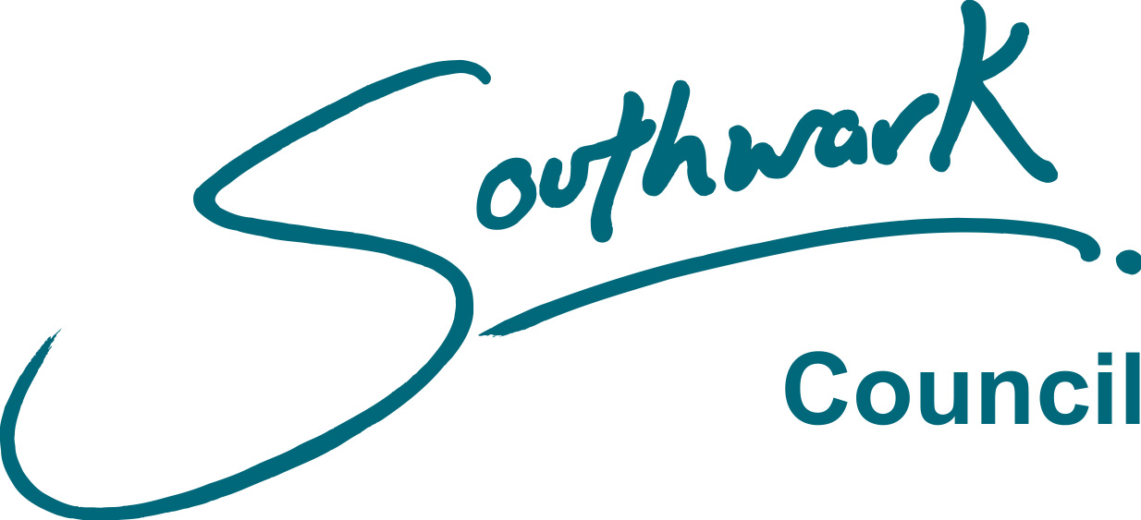
FORM PEN 41
Rev Feb 2014

LONDON BOROUGH OF SOUTHWARK

Local Government Pension Scheme
Regulations 2013

Co-habiting Partner Information
for Survivor's Pension

April 2014
CO-HABITING PARTNER FOR SURVIVOR'S PENSION

EXPLANATORY NOTES

Benefits payable on the death of a member of the Local Government Pension Scheme (LGPS) include pensions for children, for a surviving spouse or registered civil partner and, provided the scheme member paid into the LGPS on or after 1 April 2008, for a co-habiting partner.

A co-habiting partner, can be of either opposite or same sex, and must be able to make a declaration, at the time of your death, containing the information on this sheet.

To be able to make such a declaration, all of the following conditions must have applied to both you and your co-habiting partner for a continuous period of at least 2 years before the date of your death:

- both you and your co-habiting partner had been free to marry each other or enter into a civil partnership with each other, and
- you and your co-habiting partner had been living together as if you were husband and wife, or civil partners, and
- neither you or your co-habiting partner had been living with someone else as if you/they were husband and wife or civil partners, and
- either your co-habiting partner was financially dependent on you or you were financially interdependent on each other.

A declaration is not valid if all of the above conditions have not been met for a continuous period of at least 2 years prior to your death.

Your partner is financially dependent on you if you have the highest income. Financially interdependent means that you rely on your joint finances to support your standard of living. It doesn’t mean that you need to be contributing equally. For example, if your partner’s income is a lot more than yours, he or she may pay the mortgage and most of the bills, and you may pay for the weekly shopping.

You and your co-habiting partner should be aware that on your death we will have to verify that the conditions for paying a survivor’s pension have been satisfied. We may do this by, for example, asking for confirmation that you lived in a shared household with shared household spending, or your partner may be asked to demonstrate that you had a bank account or mortgage in joint names. There would be a right of appeal if we decide not to pay a pension and your partner believes that he/she has entitlement.

You are not required to provide us with information about a co-habiting partner they will be able to claim the survivor pension as long as they can prove the above. However, if you would like us to hold their information, for this purpose only and to make things easier for them at the time, you may fill in and return the form below.

If you are married or are in a registered civil partnership do not complete a survivor’s pension information form for your partner – they can produce the relevant certificate in the event of your death to claim it.

Remember to let us know of a change in your circumstances which could affect the information we hold, or if you wish to cancel it.

If you and your partner are happy for us to hold this information for this purpose, please complete the form and return it to: Pensions Services, 2nd Floor, Hub 1, P O Box 64529, London SE1P 5LX.

FORM NPF51
Rev Feb 2014

LONDON BOROUGH OF SOUTHWARK

THE LOCAL GOVERNMENT PENSION SCHEME

CO-HABITING PARTNER INFORMATION FOR SURVIVOR'S PENSION

Please read the notes first. If you wish to proceed, use BLOCK CAPITALS to give details about yourself and your partner as requested below.

YOUR DETAILS

Surname ……………………………………………………………………………………………………….

Forename(s) …………………………………………………………………………………………………..

Date of birth ……………………………………….. National Insurance No. ……………………………

Home Address………………………………………………………………………………………….........

……………………………………………………………………………Post Code….……………………..

Employer …………………………………………… Employee Payroll Number……………………...

PARTNER’S DETAILS

I provide the following information about my partner that I would wish to receive a survivor's pension under the Local Government Pension Scheme:

Surname …………………………………………… Title (e g Mr, Ms, Other) …………………………..

Forename(s) …………………………………………………………………………………………………...

Date of birth ……………………………………….. National Insurance No. …………………………….

Home Address …………………………………………………………………………………………..........

……………………………………………………………………………Post Code…………………………

Scheme member's signature: ……………………………………………………………….........

Date: ..………………………………………………………………………………………………..

Partner's signature: …………..…………………………………………………………………….

Date: ..………………………………………………………………………………………………..

A civil partnership is a relationship between two people of the same sex (“civil partners”) which is formed when they legally register as civil partners of each other.

