 | 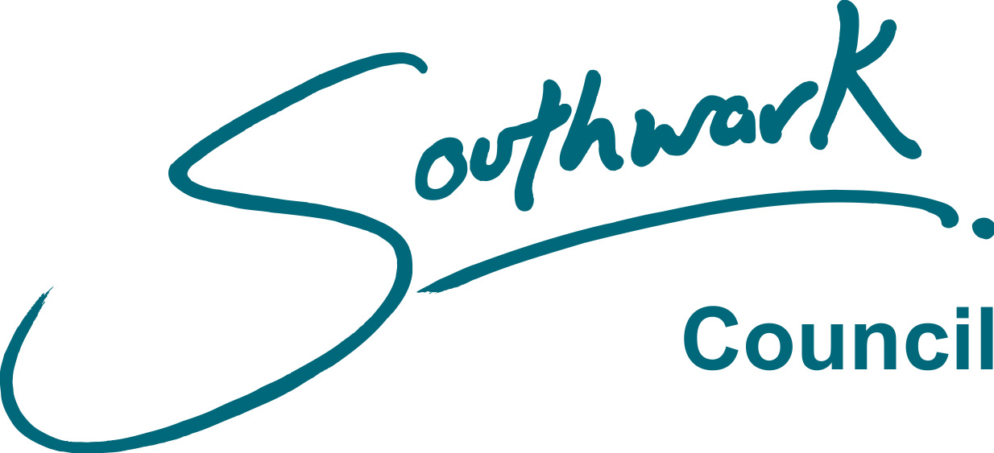
FORM PEN 02
Rev December 2016

LONDON BOROUGH OF SOUTHWARK

Local Government Pension Scheme Regulations 2013

Notes for employee leaving the LGPS

Employee leaving the Council’s service

You should read these notes if you are leaving the employment in which you were a member of the LGPS. Your employer will complete a form notifying Pensions Services that you have left the scheme. NO action can be taken on your pension benefits until the form is received by Pensions Services.

A. With immediate benefit entitlement

The following table gives details of the benefits payable for the different reasons for leaving.

Reason for Leaving | Age | Reckonable and  Qualifying Service | Notes
Normal Pension Age (NPA) | SPA* (min age 65) | Any length | (1)
Voluntary Resignation | 55 - 75 | At NPA  Before NPA  After NPA | (1)  (2)  (3)
Ill-health (if certified by the Council’s doctor) | Any age  up to SPA | Minimum 2 years' service | (4)
Redundancy or in the interest of the efficiency of the service | 55 - SPA | Minimum 2 years' service | (5)
Flexible Retirement (Employers Consent Required) | 55 - SPA | Minimum 2 years' service | (6)

Notes:-
(1) Normal benefits payable immediately or preserved benefits**.
(2) Reduced benefits payable immediately or preserved benefits**
(3) Increased benefits payable immediately or preserved benefits**.
(4) Normal benefits (based on tiering) payable immediately.
(5) Normal benefits payable immediately on actual service only.
(6) Reduced benefits payable immediately.
* SPA – Your State Pension Age (which may be 65 or later)
** Preserved benefits must be drawn by age 75.

On receipt of the completed Form PEN02 from your employer, Pensions Services will send you full details of your entitlement to benefits.
The above Regulations require you to give three month’s notice of your intention to draw your benefits if you are leaving between the ages of 55 and 75 and wish to do so. It is recommended that you ask for an estimate of the benefits that you will receive at the date you wish to take them and also the benefits at the date they would be unreduced so that you can decide which payment date suits you best. This is especially important if you want them before your NPA as reductions are likely to apply and they are bigger the earlier you wish to take them.

B. Leaving before retirement

(for example voluntary resignation, transfer to another Local Authority, dismissal, etc.)

If you leave employment before becoming entitled to immediate payment of retirement benefits, you may have one or more of the following options available to you.

(1) Payment of a transfer value to your new employer’s pension scheme.

(2) Payment of a transfer value to an insurance company or other financial institution to purchase a personal pension.

(3) Preserved benefits.

(4) Refund of contributions.

(1) Transfer to another Pension Scheme (Including another Local Authority)

If your new employer’s pension scheme is a public sector scheme, e.g. Civil Service, Health Service, Police or Fire schemes, or is a scheme that is a member of the public sector transfer arrangements, a transfer is possible. It is usually worthwhile to transfer your pension rights as the schemes operating these special arrangements use the same methods of transfer value calculation. Before you make a final decision further details will be sent to you.

A transfer is also possible to a private pension scheme provided it is approved by the Inland Revenue. Although the transfer value will be calculated on an equitable basis there is no guarantee that it will purchase the same level of benefits in your new scheme. It is essential that you obtain full information from your new scheme administrators before you make a final decision.

If you wish to consider transferring your pension rights, either to a public sector scheme or to a private sector scheme, you should inform your new employer when you join their scheme as there may be time limits for your new scheme accepting transfers. Your new employer will then contact Pensions Services, who will send your employer full details of the transfer value and the alternative benefits available. It is up to you to find out what pension rights your new scheme is prepared to offer before you make up your mind.

(2) Transfer to a Personal Pension Scheme

It is also possible to have a transfer value paid to a personal pension arrangement set up by a bank, building society or other financial institution. A transfer will be paid to the company who will invest it on your behalf. There is no guarantee of the amount that will be in your pension fund when you retire as this depends on the investment performance of the company concerned. You should also be aware that the agent's commission and the administrative cost of setting up the personal pension plan will be deducted from the transfer value paid to the company. A review of the mis-selling of Personal Pensions has been undertaken by the main investment watchdog, The Financial Services Authority and as a result, many companies have been ordered to pay compensation. You are advised to take independent financial advice before proceeding with this option.

(3) Preserved Benefits

Provided you have at least 2 years service you can opt to leave your pension rights in the Council’s Pension Scheme.

‘Preserved’ benefits are calculated in the same way as normal retirement benefits and are based on your pensionable pay and service up to the date you leave the scheme, however, your benefits will be retained by Southwark until such time as they become payable. The date your benefits become payable will normally be between the ages of 55 and 75, it is your choice as to when you want to draw them, they will generally be reduced if taken before NPA or increased if taken later. In any case preserved benefits must be taken before you attain the age of 75. Your preserved benefits can be paid early if you become permanently incapacitated and the Council’s Medical Adviser certifies that if you were still in service you would have been retired on the grounds of ill-health. Preserved benefits are increased in line with the cost of living index from the date you leave employment with the Council. If you are leaving Local Government but return later, your preserved benefits may be transferred to your new authority.

(5) Refund of Contributions

If you leave with less than 2 years total membership in the scheme you may normally apply for a refund of your contributions. However, you cannot have a refund if:

- you become a pensionable employee in another local authority pension scheme within 1 month and 1 day after your last day of service, or

- you leave after the beginning of the tax year in which you reach state pension age.

- you have other pension rights in the LGPS, under HMRC rules a refund would remove your entitlement to those benefits.

If you are entitled to a refund but return to local government after 1 month and 1 day of leaving the Council but before you receive payment you could lose your entitlement to the refund. You may also decide to defer payment of the refund for up to 5 years, you may wish to do this if you want to retain the option of transferring the benefits to another scheme that you may join within that 5 year period.

It is stressed that in most cases preserved benefits or a transfer are of far greater value than a refund. Once you receive a refund to which you are entitled you lose all pension rights in respect of that service. You cannot repay those contributions if your circumstances alter or you change your mind.

Amount of refund

You may only have a refund of your own contributions; you are not entitled to any contributions paid by the Council.

Any refund you receive will be made less the following deductions:-

- the employee’s share of the ‘contribution equivalent premium’ (CEP) which must
be paid to secure your rights in the State Second Pension Scheme for any service before 6th April 2016. .

(b) 20% tax on the balance.

Application for a refund

If you decide to take a refund you should:

complete Form NPF03 and send it to Pensions Services. This form must not be completed until at least one month and one day after your last day of service with the Council.

Payment of refund

Payment will only be made either directly to a bank account. Payment will generally be made within two to three months after your application forms are received by Pensions Services.

(6) General

Last day of service

If you are resigning, and joining another local authority and your last working day is a Friday or Saturday you are advised to enter as your ‘last day of service’ the date of the Sunday following (or where a Bank Holiday follows that Sunday the date of the Bank Holiday). This will safeguard your position regarding:

(a) service for pension purposes if you later transfer your service

(b) service for redundancy etc.

(c) in the case of salaried employees, payment for those days.

Local Authority

Any reference to a local authority also includes an Admitted Body, i.e. a body whose employees are admitted to a local authority pension fund.

These notes are for guidance only and are not a comprehensive statement of the law. They do not apply if the resignation or dismissal is because of grave misconduct or fraud committed in connection with the employment.

Any enquiry regarding individual rights should be made direct to Pensions Services at:

Southwark Council
Pension Services
2nd Floor
Hub 1 Area B
PO Box 64529
London
SE1P 5LX

Tel: 020 7525 4924

Email: lbspensions@southwark.gov.uk

