**London Borough of Southwark**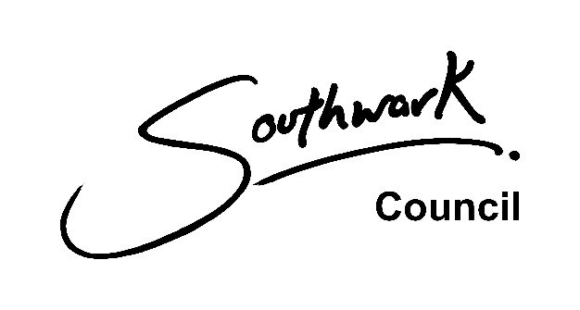

**Neighbourhood Area Application**

**Name of the proposed Neighbourhood Area:**

**Contact details:**

Please provide the name of your organisation, full name, address, email address, telephone number.

By submitting this form, you agree to make this information publicly available.

|  |  |
| --- | --- |
| **Checklist of attachments** | **Included**  **(Y/N)** |
| 1. An OS Map at a minimum of 1:10,000 scale showing the proposed neighbourhood area. |  |

**Questions**

|  |  |
| --- | --- |
| **Question** | **Response** |
| How have you considered different routes to achieving your ambitions for your neighbourhood? |  |
| What are the opportunities and benefits of producing a Neighbourhood Plan for your area? |  |
| Is there already a Neighbourhood Plan for this area? |  |
| How does this plan relate to the boundaries of other neighbourhood areas? |  |
| What is the neighbourhood area to which the Neighbourhood Plan will relate? |  |
| What are the alternative boundaries that you have considered and why did you choose the boundary proposed? |  |
| What are the physical characteristics, planning and any other reasons that you considered for choosing the boundary? |  |
| Have you consulted a range of local people, partners, businesses, community groups, residents, councillors and other stakeholders to assess levels of interest?  *What did they say?*  *Where did they think the boundary should be?*  *How did they relate to the proposed neighbourhood?*  *How many did you consult?*  *What were the demographics?* |  |
| How have you resolved conflict with other groups who have issues with your proposal? |  |
| When and how did you involve LB Southwark Planning Policy officers to discuss the reasons for the boundary chosen? |  |
| What did your review of existing local policy to identify how well it covers community concerns and aspirations find? |  |
| What are the resource implications (time and money) of producing a  Neighbourhood Plan?  *How will you provide them?* |  |
| When and how did you involve LB Southwark Planning Policy officers to clarify the support it can offer under its duty to support? |  |
| Who are the 21 members of your neighbourhood forum? Do you have a resident, business and ward member on the forum? How is this group representative of the demographics of the proposed area?    Please list the names and addresses at the end. I will contact the members for them to agree that they are on the Neighbourhood Forum. |  |
| Please enclose your constitution. We would recommend that this should meet the standards set out by the charity commission. This is required for us to make a decision on whether the group could operate as a Neighbourhood Forum. |  |

**Please return this form to with all the required attachments to:**

**Juliet Seymour**

**Head of Policy, Building Control and the Historic Environment**

**London Borough of Southwark 160 Tooley Street SE1P 5LX**

**Alternatively, please email the completed form with all the required attachments, marked for the attention of Juliet Seymour (Head of Policy, Building Control and the Historic Environment) to:**

[**planning.policy@southwark.gov.uk**](mailto:planning.policy@southwark.gov.uk)

This application form is based on the DCLG Good practice guidance prepared by Locality: <https://neighbourhoodplanning.org/toolkits-and-guidance/create-neighbourhood-plan-step-by-step-roadmap-guide/>

We always process and hold your data in a secure way by:

* only giving access to people who are authorised to see your data
* using secure systems that are protected by firewalls and passwords
* encrypting your information
* changing a key identifier (for example your name) so external people cannot identify you (pseudonymisation)
* carrying out regular tests of our IT systems
* carrying out audits of the data we hold
* regularly reviewing our data handling procedures
* regularly training our staff in data protection and information governance

We will store your data on UK servers. If we have to send your data to another organisation, it might get put on a system in the European Economic Area (EEA). The same data protection standards protect your rights in the UK, EU and EEA.

We have procedures in place to deal with a suspected data security breach. We will notify you and any regulator of a suspected data breach, where required by law.