**London Borough of Southwark**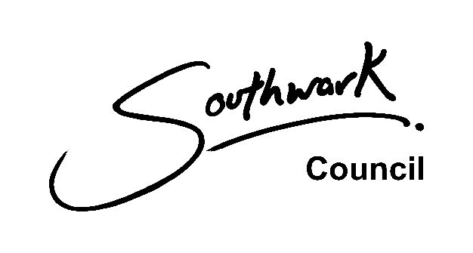

**Neighbourhood Forum Application**

**Name of the Neighbourhood Area:**

**Name of the proposed Neighbourhood Forum:**

**Contact details of one member to be made public:**

* Please provide full name, address, email address, telephone number.
* Please state whether the member is a resident in the area, a worker in the area, or an elected member for the area.

By providing this, you agree to make this information publicly available.

|  |  |
| --- | --- |
| *Section 61F(5) of the Town and Country Planning Act 1990 sets out the qualifying criteria for neighbourhood forums, namely a community group or organisation established with the express purpose of promoting the social, economic and environmental well-being of a particular neighbourhood area (a forum may also be constituted from trades, professions or other businesses in such an area).*  Please ensure the following attachments are provided: | |
| **Checklist of attachments** | **Included**  **(Y/N)** |
| 1. A copy of the written constitution of the proposed forum. |  |
| 1. An OS Map at a minimum of 1:10,000 scale showing the proposed neighbourhood area. |  |
| 1. A statement explaining how the proposed forum is established to promote or improve the social, economic and environmental wellbeing of the area. a statement to explain how the forum meets the conditions contained in the 1990 Act. |  |
| 1. A statement explaining that membership is drawn from different places in the neighbourhood area, and from different sections of the community. |  |
| 1. A statement explaining that membership is drawn from different places in the neighbourhood area, and from different sections of the community.   The statement should explain that membership is open to those who live in the area, work in the area, or are elected members for the area.  The statement should explain what steps have been taken in order to attempt to secure membership of individuals from different places in the area, and from different sections of the community. |  |
| 1. A list of at least 21 members of the proposed forum. For each member, please detail: 2. Their name 3. Their address 4. Their status: whether they area a resident in the area, a worker in the area, or an elected member for the area. 5. Preferred contact details e.g. email address (we   reserve the right to contact each member to confirm their membership of the proposed Forum)  *These details will not be made public and will be processed and held in compliance with Southwark Council data protection policies (see below).* |  |
| 1. A statement confirming that members of the proposed forum have all agreed to have their name, status and postcode published (their full address and preferred contact details will be redacted). |  |

**Additional Questions**

|  |  |
| --- | --- |
| **Question** | **Response** |
| How have you considered different routes to achieving your ambitions for your neighbourhood? |  |
| What are the opportunities and benefits of producing a Neighbourhood Plan for your area? |  |
| How does your proposal relate and affect other existing Neighbourhood Forums in the surrounding area?  *Does it support or conflict with their policies? If so, how?* |  |
| Have you consulted a range of local people, partners, businesses, community groups, residents, councillors and other stakeholders to assess levels of interest?   * *What did they say?* * *Where did they think the boundary should be?* * *How did they relate to the proposed neighbourhood?* * *How many did you consult?* * *What were the demographics?* |  |
| How have you resolved conflict with other groups who have issues with your proposal? |  |
| When and how did you involve LB Southwark Planning Policy officers to clarify the support it can offer under its duty to support? |  |
| How does your neighbourhood forum reflect the needs of the people in the local area?  *This should include consideration of those with protected characteristics, as defined by the Equalities Act 2010* |  |
| How will this Neighbourhood Forum prepare a plan that complies with the Development Plan?  What is the expected timeframe for the submission of the plan and what processes are in place? |  |
| What other organisations and groups will you work with? |  |
| Is there already a Neighbourhood Forum for that area? |  |

**Please return this form to with all the required attachments to:**

**Juliet Seymour**

**Head of Policy, Building Control and the Historic Environment**

**London Borough of Southwark 160 Tooley Street SE1P 5LX**

**Alternatively, please email the completed form with all the required attachments, marked for the attention of Juliet Seymour (Head of Policy, Building Control and the Historic Environment) to:**

[**planning.policy@southwark.gov.uk**](mailto:planning.policy@southwark.gov.uk)

This application form is based on the DCLG Good practice guidance prepared by Locality: <https://neighbourhoodplanning.org/toolkits-and-guidance/create-neighbourhood-plan-step-by-step-roadmap-guide/>

We always process and hold your data in a secure way by:

* only giving access to people who are authorised to see your data
* using secure systems that are protected by firewalls and passwords
* encrypting your information
* changing a key identifier (for example your name) so external people cannot identify you (pseudonymisation)
* carrying out regular tests of our IT systems
* carrying out audits of the data we hold
* regularly reviewing our data handling procedures
* regularly training our staff in data protection and information governance

We will store your data on UK servers. If we have to send your data to another organisation, it might get put on a system in the European Economic Area (EEA). The same data protection standards protect your rights in the UK, EU and EEA.

We have procedures in place to deal with a suspected data security breach. We will notify you and any regulator of a suspected data breach, where required by law.